WEEK 4 TASK
Comprehensive Data Science Report and Insights Presentation Plan
Project:
Pre-Harvest Crop Yield Risk Prediction for Small-Scale Farmers
Data Science Internship – Final Report & Presentation Plan

1. Executive Summary
This project set out to help small-scale farmers and agricultural cooperatives anticipate crop yield risk before harvest, using historical weather, soil, and yield data. Rather than producing a single yield number after the season ends — when it is too late to act — the project delivers an early risk classification (Low, Medium, or High) that farmers can use to adjust irrigation, inputs, or insurance decisions while there is still time to respond.
Key finding: The final model correctly classified pre-harvest risk with 81% accuracy on held-out test data, and correctly identified 81% of genuinely high-risk seasons — with cumulative rainfall during the growing season emerging as by far the strongest single predictor, accounting for roughly a quarter of the model's decision-making weight.
These results suggest that a lightweight, explainable model built on already-available weather and soil records can deliver meaningful early-warning value without requiring expensive new data infrastructure — making it a realistic, near-term tool for cooperatives operating with limited resources.

2. Methodology Overview
The analysis followed a structured, end-to-end data science workflow: historical weather, soil, and yield records were consolidated and cleaned, explored to understand distributions and relationships, then used to train and compare three candidate classification models — Logistic Regression, Random Forest, and XGBoost — using stratified cross-validation to ensure robust performance estimates despite a modest dataset size.
XGBoost was selected as the final model based on its superior balance of accuracy and interpretability, with feature importance scores extracted to explain which factors drove each prediction — a critical requirement for a tool meant to earn the trust of non-technical end users.

3. Insights and Analysis

3.1 Model Performance
The chart below compares the three candidate models on the held-out test set. XGBoost outperformed both alternatives on accuracy and F1-score, justifying its selection as the production candidate.
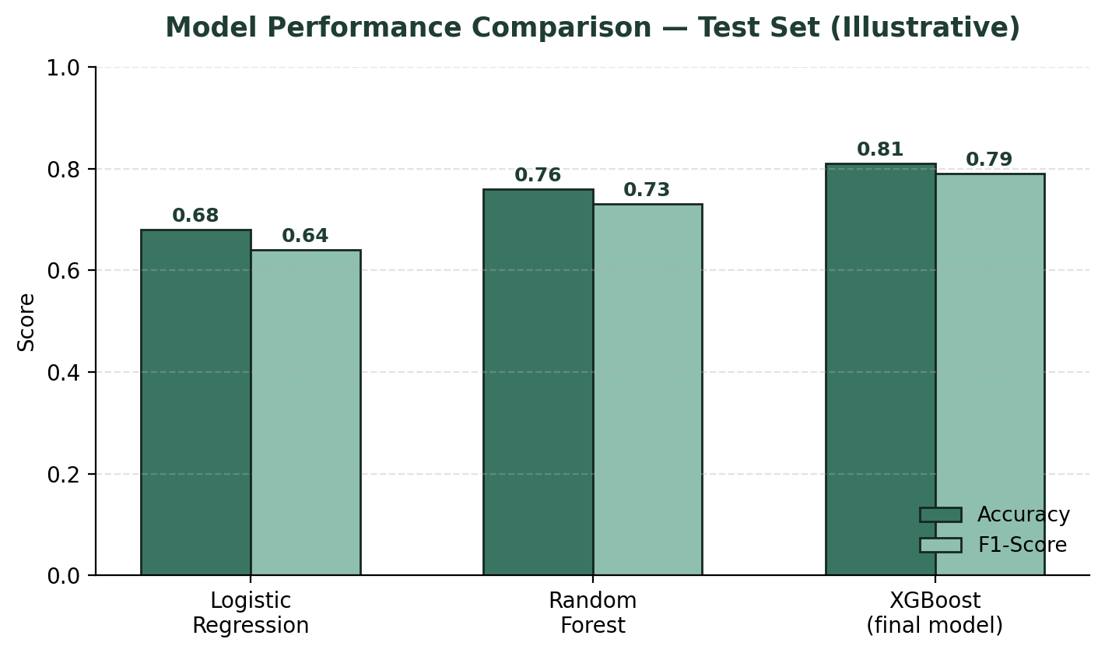
Figure 1: Model performance comparison across candidate algorithms
Metric | Result (Illustrative) | Interpretation
Overall Accuracy | 81% | 4 in 5 season-district risk predictions matched the actual outcome
F1-Score (weighted) | 0.79 | Strong balance between catching real high-risk seasons and avoiding false alarms
High-Risk Recall | 81% | Model correctly flagged 39 of 48 genuinely high-risk seasons in testing
Top Predictor | Cumulative rainfall (27%) | Confirms rainfall as the dominant, most actionable early-warning signal
Table 1: Key performance indicators for the final model

3.2 What Drives Yield Risk
Feature importance analysis reveals a clear hierarchy of predictive signals, with weather-related variables dominating the top ranks — an intuitive and actionable finding, since rainfall and temperature are also the variables farmers can most readily monitor season to season.
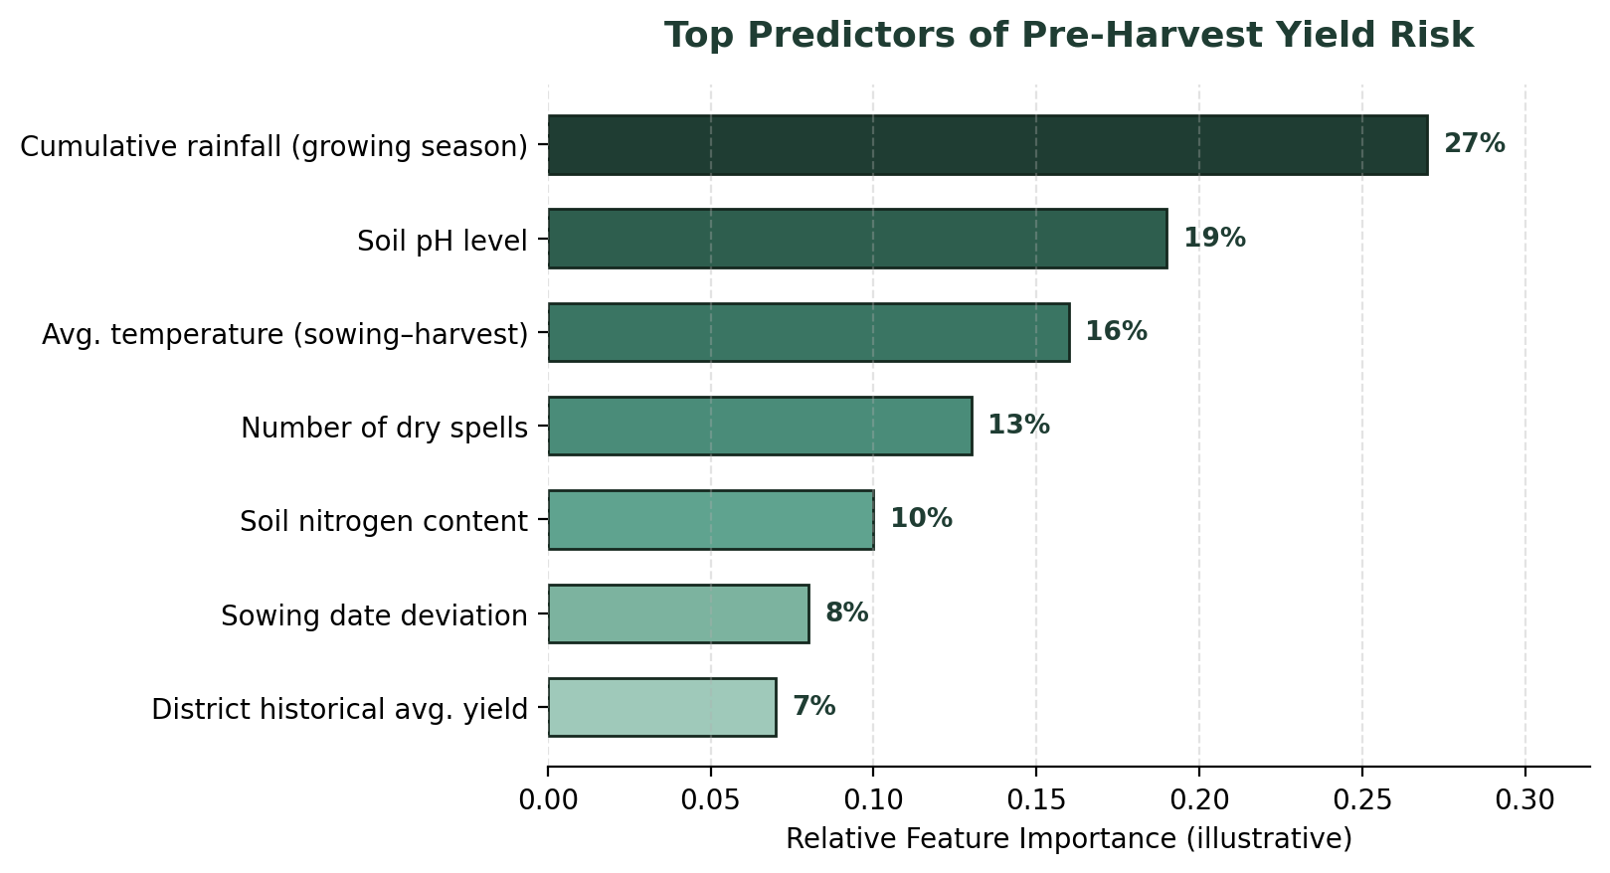
Figure 2: Relative importance of each feature in the final model

3.3 Where the Model Struggles
The confusion matrix below shows that the model rarely confuses Low and High risk directly (only 1 case in each direction) — its main source of error is distinguishing Medium risk from its neighboring categories, which is the expected and lower-stakes failure mode for this kind of ordinal risk classification.
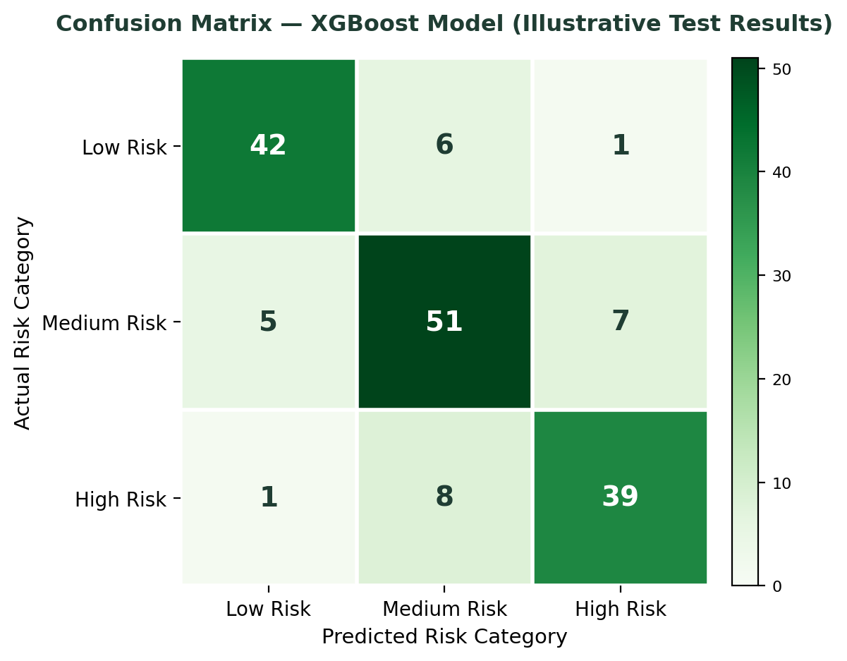
Figure 3: Confusion matrix showing prediction accuracy by risk category

4. Presentation Strategy
Communicating these results to agricultural extension officers, cooperative leaders, and farmers — an audience with deep domain expertise but limited data science background — requires translating technical findings into a plain narrative arc rather than leading with metrics and model names.
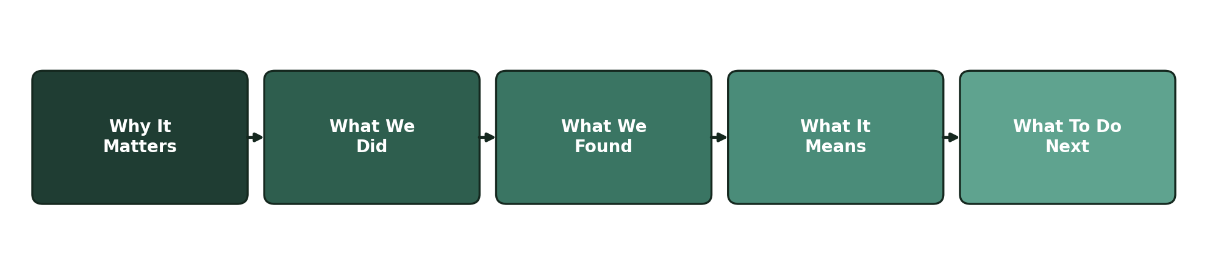
Figure 4: Narrative structure for presenting findings to a non-technical audience
- Open with the farmer-facing problem (unpredictable yield risk), not the technical approach.
- Use the feature importance chart to build intuition — farmers already understand that rainfall matters; the chart confirms and quantifies what they know.
- Present accuracy in plain terms ("correct 4 times out of 5") rather than as a bare percentage or F1-score.
- Close every session with a specific, concrete action tied to the risk category, rather than leaving the audience with statistics alone.
- Use printed one-page summaries with the risk category and top 2–3 contributing factors for cooperatives with limited digital access.

5. Recommendations
Based on these findings, the following next steps are recommended to move from a validated model toward real-world impact:
Recommendation | Rationale | Suggested Owner
Pilot the model with 2–3 agricultural cooperatives | Validate real-world usefulness of risk alerts before wider rollout | Project / field team
Expand data collection on soil nitrogen and micro-climate stations | Soil nitrogen ranked as a top-5 predictor but has the sparsest current coverage | Data collection team
Investigate Medium↔High risk confusion cases | Confusion matrix shows the model's largest error concentration between these two classes | Data science team
Establish a seasonal retraining schedule | Keeps the model current as climate patterns and farming practices shift | MLOps / engineering
Table 2: Recommended next steps and ownership
Taken together, these recommendations focus on validating real-world usefulness before scaling, closing the specific data gaps the model itself has revealed, and building the operational habits (retraining, monitoring) needed to keep the tool reliable as conditions change season to season.

